Tugas web1 pertemuan ke2

Nama : Andeas Devin Aprilio
Npm : 5520125035
Shift : 3 Web1

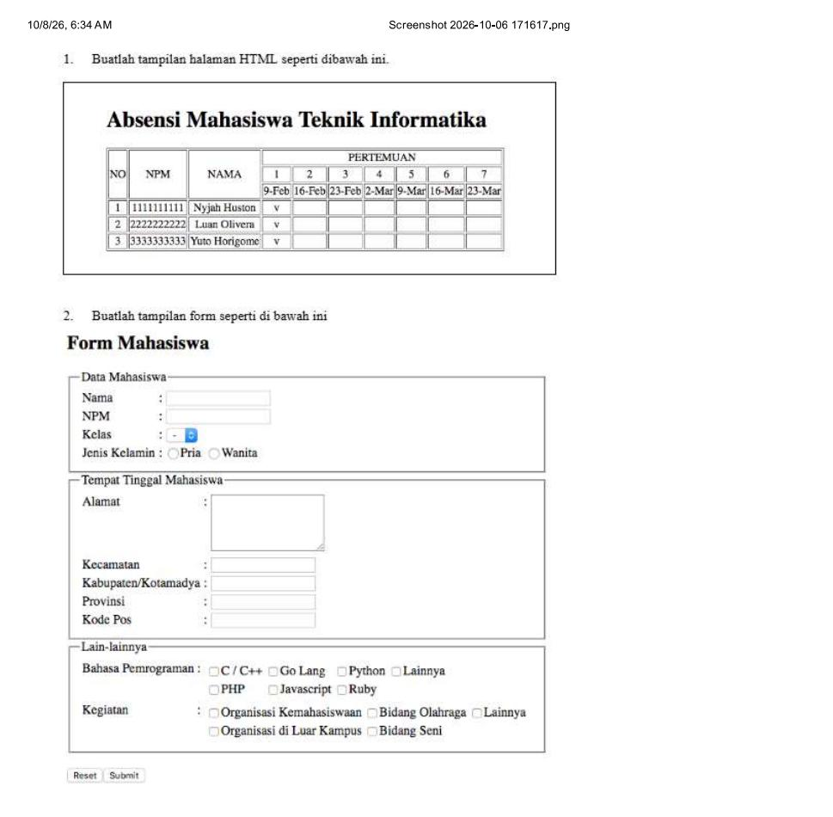
<!DOCTYPE html>
<html>
<head>
<title>Tugas HTML Mahasiswa</title>
</head>
<body>

<fieldset>
<h2 align="center">
Absensi Mahasiswa Teknik Informatika
</h2>

<table border="1" align="center"
cellpadding="3" cellspacing="1">

<tr>
<th rowspan="3">NO</th>
<th rowspan="3">NPM</th>
<th rowspan="3">NAMA</th>
<th colspan="7">PERTEMUAN</th>
</tr>

<tr>
<th>1</th>
<th>2</th>
<th>3</th>
<th>4</th>
<th>5</th>
<th>6</th>
<th>7</th>
</tr>

<tr>
<td>9-Feb</td>
<td>16-Feb</td>
<td>23-Feb</td>
<td>2-Mar</td>
<td>9-Mar</td>
<td>16-Mar</td>
<td>23-Mar</td>
</tr>

<tr>
<td>1</td>
<td>1111111111</td>
<td>Nyjah Huston</td>
<td>V</td><td></td><td></td><td></td>
<td></td><td></td><td></td>
</tr>

<tr>
<td>2</td>
<td>2222222222</td>
<td>Luan Olivera</td>
<td>V</td><td></td><td></td><td></td>
<td></td><td></td><td></td>
</tr>

<tr>
<td>3</td>
<td>3333333333</td>
<td>Yuto Horigome</td>
<td>V</td><td></td><td></td><td></td>
<td></td><td></td><td></td>
</tr>

</table>
</fieldset>

- Output
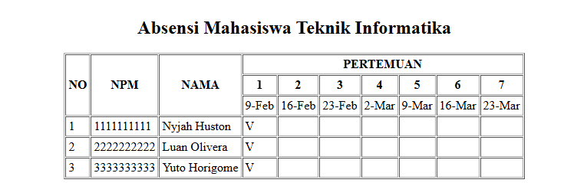

<h2>Form Mahasiswa</h2>

<form action="#" method="get">

<fieldset>
<legend>Data Mahasiswa</legend>

<table cellpadding="2">
<tr>
<td>Nama</td>
<td>:</td>
<td><input type="text" name="nama"></td>
</tr>

<tr>
<td>NPM</td>
<td>:</td>
<td><input type="text" name="npm"></td>
</tr>

<tr>
<td>Kelas</td>
<td>:</td>
<td>
<select name="kelas">
<option value="">-</option>
<option value="A">A</option>
<option value="B">B</option>
<option value="C">C</option>
</select>
</td>
</tr>

<tr>
<td>Jenis Kelamin</td>
<td>:</td>
<td>
<input type="radio" name="jk" value="Pria">Pria
<input type="radio" name="jk" value="Wanita">Wanita
</td>
</tr>
</table>
</fieldset>

<fieldset>
<legend>Tempat Tinggal Mahasiswa</legend>

<table cellpadding="2">
<tr>
<td>Alamat</td>
<td>:</td>
<td>
<textarea name="alamat"
rows="5" cols="20"></textarea>
</td>
</tr>

<tr>
<td>Kecamatan</td>
<td>:</td>
<td><input type="text" name="kecamatan"></td>
</tr>

<tr>
<td>Kabupaten/Kotamadya</td>
<td>:</td>
<td><input type="text" name="kabupaten"></td>
</tr>

<tr>
<td>Provinsi</td>
<td>:</td>
<td><input type="text" name="provinsi"></td>
</tr>

<tr>
<td>Kode Pos</td>
<td>:</td>
<td><input type="text" name="kodepos"></td>
</tr>
</table>
</fieldset>

<fieldset>
<legend>Lain-lainnya</legend>

<table cellpadding="2">
<tr>
<td>Bahasa Pemrograman</td>
<td>:</td>
<td>
<input type="checkbox" name="bahasa[]" value="C/C++">C/C++
<input type="checkbox" name="bahasa[]" value="Go Lang">Go Lang
<input type="checkbox" name="bahasa[]" value="Python">Python
<input type="checkbox" name="bahasa[]" value="Lainnya">Lainnya
<br>
<input type="checkbox" name="bahasa[]" value="PHP">PHP
<input type="checkbox" name="bahasa[]" value="Javascript">Javascript
<input type="checkbox" name="bahasa[]" value="Ruby">Ruby
</td>
</tr>

<tr>
<td>Kegiatan</td>
<td>:</td>
<td>
<input type="checkbox" name="kegiatan[]" value="Organisasi Kemahasiswaan">Organisasi Kemahasiswaan
<input type="checkbox" name="kegiatan[]" value="Bidang Olahraga">Bidang Olahraga
<input type="checkbox" name="kegiatan[]" value="Lainnya">Lainnya
<br>
<input type="checkbox" name="kegiatan[]" value="Organisasi di Luar Kampus">Organisasi di Luar Kampus
<input type="checkbox" name="kegiatan[]" value="Bidang Seni">Bidang Seni
</td>
</tr>
</table>
</fieldset>

<br>

<input type="reset" value="Reset">
<input type="submit" value="Submit">

</form>

</body>
</html>

- Output
